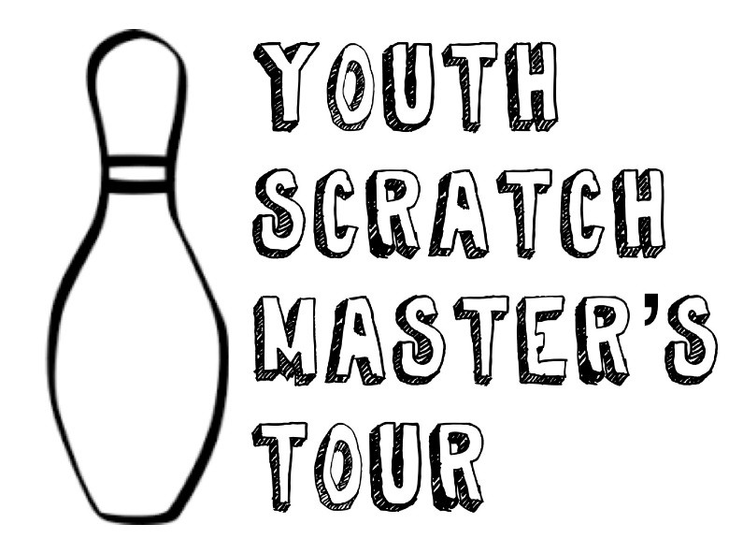
November 19 & 20, 2022
West Acres Bowling Center
749 N Ridge Rd.
Wichita, KS 67212

Mail Entry & Check to: YSMT
P.O. Box 1212, Newcastle, OK 73065
OR
Online registration/on site payment: www.youthscratchmasterstour.com

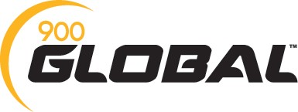

Event options (please place an ‘x’ by which events you wish to attend):
Baker Doubles ($40.00 each): Saturday, November 19, 2022 at 6:00pm
Master’s Event ($85.00 entry): Sunday, November 20, 2022 at 9:00am
Optional Junior Gold Side event offered at an additional cost on site

Baker Doubles Divisions: U30 Baker Doubles | Open Baker Doubles

Master’s Event Division: U12 Mixed | U15 Mixed | Open (U18) Girls | Open (U18) Boys
Name: USBC:
Address:
City/State/Zip:
Phone Number: E-mail:
DOB:
I consent to have my child’s photograph used on social media: YES / NO

Youth Scratch Master’s Tour Website: www.youthscratchmasterstour.com
Facebook: Youth Scratch Master’s Tour Phone Number: 580-916-1026 Email: ysmtbowling@gmail.com

office use only: entry received: payment method: payment needed: email sent:

Youth Scratch Master’s Tour: Baker Doubles Event Rules
ELIGIBILITY: Open to any USBC Youth member. You may buy your membership on site.

DIVISIONS: There will be two age divisions for Baker Doubles, a U30 Baker doubles (combined age 29 and under) and an Open Division (combined age 30 and up). Divisions will be based on age as of 8/1/2022. Divisions will be combined if not enough entries are received. Divisions will make with three teams per division.

ENTRY FEES: $40.00 cash or card. Checks may be mailed prior to the event only, make checks payable to YSMT. Pre-registration is preferred, but not required. Limited registration on site. Breakdown is $15 to scholarship and $25 towards lineage/awards/expenses. Scholarships will be awarded based on entries per division.

FORMAT: Scratch bowling –Tournament will consist of forming a doubles team any gender. You will bowl 6 games following the Baker Format. Bowling center house shot. Scholarships are awarded based on entries. Dress code is casual, no athletic shorts, no jeans with holes, t-shirts or jerseys allowed, but must be appropriate (no sexual content, no depictions of drugs or alcohol). Tournament dress is always allowed. Female’s shorts must be an appropriate length (no short shorts).

Youth Scratch Master’s Tour: Master’s Event Rules
ELIGIBILITY: Open to any USBC Youth member. You may buy your membership on site.

DIVISIONS: U12 Mixed Division (birthday must be 8/1/2010 or later), U15 Mixed Division (birthdate must be 8/1/2007 to 7/31/2010), Open Girls and Open Boys (birthdate 8/1/2004 to 7/31/2007). Divisions need four (4) bowlers to make. U12 will combine with U15 if not enough in the U12 division. If not enough in the U15 division, they will split by gender to Open Girls and Open Boys. Bowlers are allowed to bowl “up” if they do not wish to be in the U12 or the U15 Mixed Division. Any division bowler can opt to bowl in Open Girls or Open Boys if they choose to bowl up.

ENTRY FEES: $85.00 cash or card on site. Checks may be mailed prior to the event only, make checks payable to YSMT. Pre- registration is preferred, but not required. Walk-ins are accepted. Breakdown is $40 towards SMART, $37 towards lineage/expenses/ awards, $8 to Tournament of Champions.

FORMAT: Scratch bowling, sport shot - Qualifying will consist of 5 games, moving each game. Bowlers will shift one pair to the right for each game, in their respective division. Top 8 per division advance to match play after qualifying. If there is a tie in the top 8, highest game will determine seed. If a tie between 8 & 9, there will be a 2-frame roll off.

MATCH PLAY: There will be re-oiling between qualifying and match play. Bowlers may resurface and/or clean any equipment between qualifying and match play. Bowling will begin once the lanes are ready. Bowlers will receive six (6) minutes of practice before first match, 3 minutes for each following match. Match play will be best 2 of 3 games per round until we have crowned a champion per division. If there is a tie, a whole game will be bowled. You will not bowl consecutive match play rounds on the same pair of lanes. Based on lane availability, matches may be doubled up within the respective divisions. Match play may be conducted on the same lane as qualifying.

DRESS CODE: Bowlers are required to wear slacks (no jeans, shorts or leggings) and polo’s (traditional or mock collar), for the girl’s division acceptable length skirts are allowed (will be asked to change if it is not long enough). No muscles shirts or see through blouses, no headphones and no hats. Bad conduct, rudeness or profanity or abuse of center equipment will not be tolerated; bowlers conducting themselves improperly may be disqualified and or penalized by the tournament directors or center management without a refund. Any USBC youth bowlers will not be allowed to use tobacco or alcohol products. All tournament director decisions are final. Per USBC rules, a dry towel can be used in competition, if you have residue from the alley on your ball, tournament staff has cleaner and will administer the cleaner if deemed necessary.

All bowlers must have current USBC Membership (can be purchased on site) USBC rules apply

Tournament Directors: Rett Norman & Brianna Norman
Mail entries with payment to: Youth Scratch Master’s Tour, P. O. Box 1212, Newcastle, OK 73065 Checks Payable to: Youth Scratch Master’s Tour
Online registration/payment at tournament site: www.youthscratchmasterstour.com SMART #: 13448

